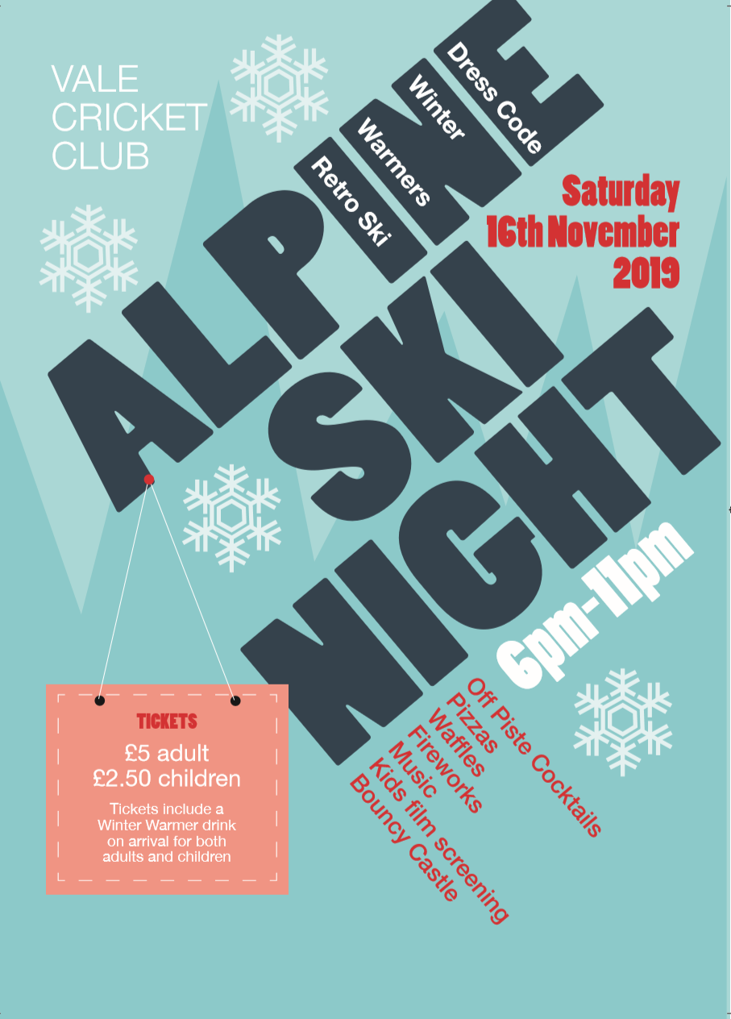

- Alpine Ski night on Sat 16th November
- Venue: Vale Cricket Club in Corntown
- Our ski instructors are doing a fantastic amount of work to make this a great evening and will be dressing up the club, side patio and shed to create an Alpine Ski venue for the night (donation of kit to help decorate club welcome).
- As well as the après ski bar the evening will include;

  - Hot drinks on arrival
  - Off Piste Cocktails
  - Pizza van for food
  - Waffles
  - Ice Cream stall
  - Fireworks
  - Music
  - Kids film screening (upstairs)
  - Snow dome bouncy castle

- Tickets are priced at £2.50 for children (U16) and £5 for Adults (Sarah, Deb Lewis and I have tickets)
- Please contact Sarah 07970 809288, Deb 07876 680825 or Gareth 07540 079978 for ski passes (tickets).

